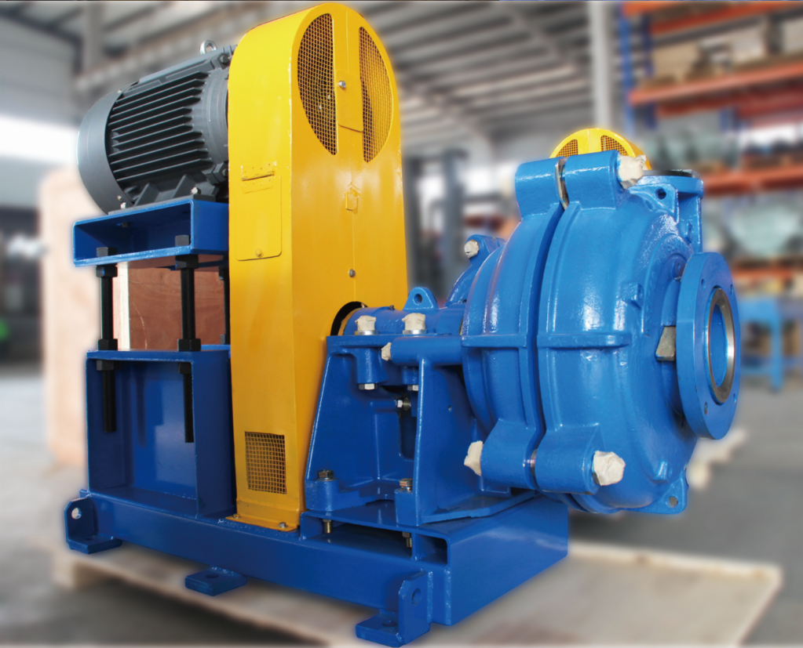

**Pump Model**

**Pulleys, Belts & Guard**

**Yes / No**

**MOTOR REQUIRED?**

KW

PHASE

POLE

VOLTAGE

IP RATING

PUMP SPEED

**PUMP GLAND ARRANGEMENT?**

GLAND

EXPELLER

MECHANICAL SEAL

**PUMP DATA**

TOTAL HEAD

FLOW RATE

SG

Ph

Pump & Motor Pulleys, Belts and Guard

Pump Model

ZV Pump Base

Electric Motor KW Size

Motor Support & Threaded Bar

**Select Pump Orientation Requirement - _________ Position**

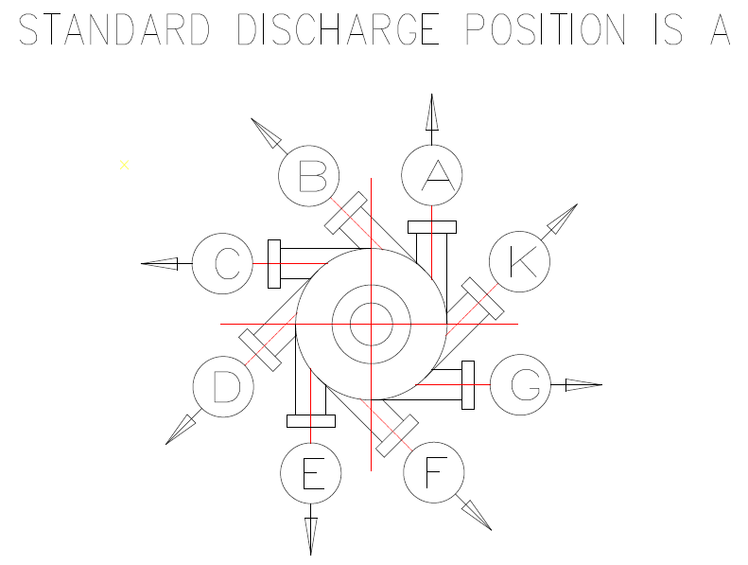

**Pump Drive Arrangement – Select the Required Drive - ___________ Arrangement**

